Post Traumatic Stress Disorder

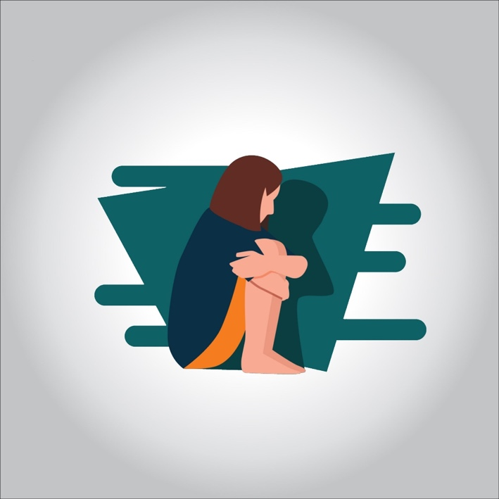

**Post-traumatic stress disorder (PTSD) is a mental health disorder that begins after a traumatic event. That event may involve a real or perceived threat of injury or death.**

**This can include:**

* **a natural disaster like an earthquake or tornado**
* **military combat**
* **physical or sexual assault or abuse**
* **an accident**

**People with PTSD feel a heightened sense of danger. Their natural fight-or-flight response is altered, causing them to feel stressed or fearful, even when they’re safe.**

**PTSD used to be called “shell shock” or “battle fatigue” because it often affects war veterans.**

**But PTSD can happen to anyone at any age. It occurs as a response to chemical and neuronal changes in the brain after exposure to threatening events. Having PTSD doesn’t mean you’re flawed or weak.**

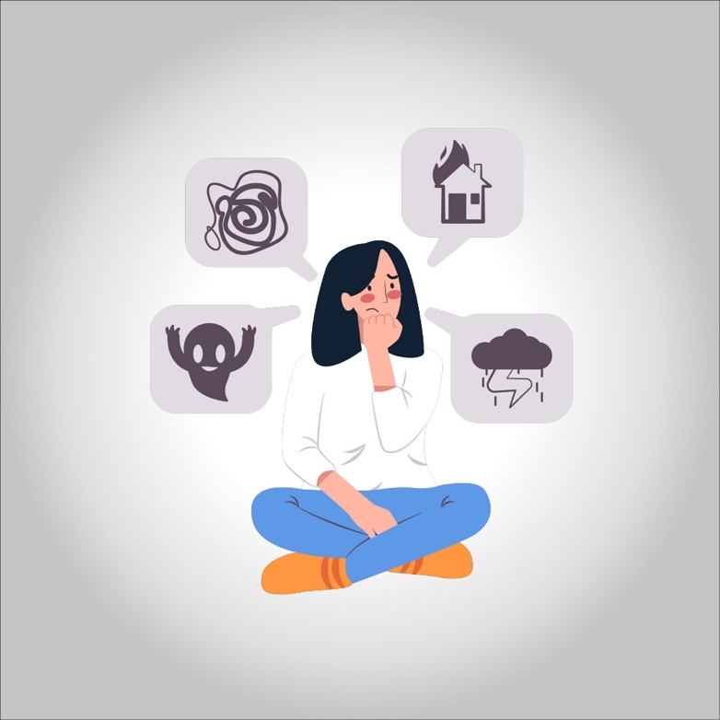

**PTSD symptoms**

**PTSD can disrupt your normal activities and your ability to function. Words, sounds, or situations that remind you of trauma can trigger your symptoms.**

**Symptoms of PTSD fall into four groups:**

**Intrusion**

* **flashbacks where you feel like you relive the event over and over**
* **vivid, unpleasant memories of the event**
* **frequent nightmares about the event**
* **intense mental or physical distress when you think about the event**

**Avoidance**

**Avoidance, as the name implies, means avoiding people, places, or situations that remind you of the traumatic event.**

**Arousal and reactivity**

* **trouble concentrating**
* **startling easily and having an exaggerated response when you’re startled**
* **a constant feeling of being on edge**
* **irritability**
* **bouts of anger**

**Cognition and mood**

* **negative thoughts about yourself**
* **distorted feelings of guilt, worry, or blame**
* **trouble remembering important parts of the event**
* **reduced interest in activities you once loved**

**In addition, people with PTSD may experience depression and panic attacks.**

**Panic attacks can cause symptoms like:**

* **agitation**
* **excitability**
* **dizziness**
* **lightheadedness**
* **fainting**
* **a racing or pounding heart**
* **headaches**

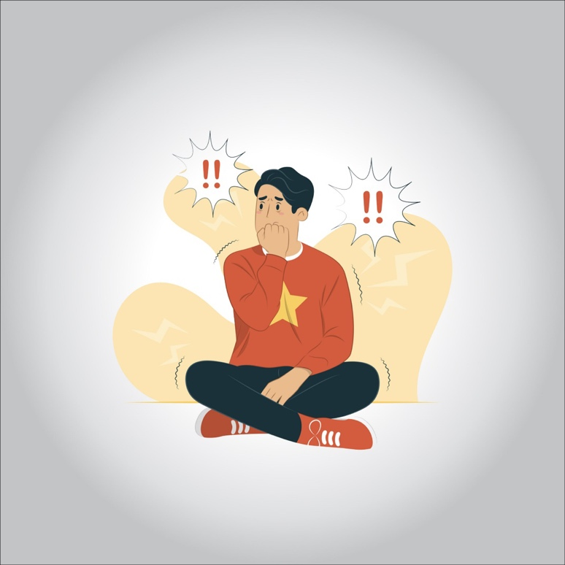

**PTSD symptoms in women**

**According to the American Psychiatric Association (APA), women are twice as likely as men to get PTSD, and the symptoms manifest slightly differently.**

**Women may feel more:**

* **anxious and depressed**
* **numb, with no emotions**
* **easily startled**
* **sensitive to reminders of the trauma**

**Women’s symptoms last longer than those of men.**

**PTSD symptoms in men**

**Men usually have the typical PTSD symptoms of re-experiencing, avoidance, cognitive and mood issues, and arousal concerns. These symptoms often start within the first month after the traumatic event, but it can take months or years for signs to appear.**

**Everyone with PTSD is different. The specific symptoms are unique to each man based on his biology and the trauma he experienced.**

**PTSD treatment**

**If you’re diagnosed with PTSD, your healthcare provider will likely prescribe therapy, medication, or a combination of the two treatments.**

**Cognitive behavioral therapy (CBT) or “talk therapy” encourages you to process the traumatic event and change the negative thinking patterns linked to it.**

**In exposure therapy, you re-experience elements of the trauma in a safe environment. This can help desensitize you to the event and reduce your symptoms.**

**Antidepressants, anti-anxiety drugs, and sleep aids may help relieve symptoms of depression and anxiety.**

**PTSD causes**

**PTSD starts in people who’ve been through or witnessed a traumatic event like a natural disaster, military combat, or assault. Most people who experience one of these events have no problems afterward, but a small percentage develop PTSD.**

**Trauma may cause actual changes to the brain.**

**However, it’s unknown whether they had a smaller hippocampal volume before the trauma or if the trauma resulted in a decrease in hippocampal volume.**

**People with PTSD may also have abnormal levels of stress hormones, which may set off an overreactive fight or flight response.**

**Medical PTSD**

**A life-threatening medical emergency can be just as traumatic as a natural disaster or violence.**

**Research Trusted Source shows that about 1 in 8 people who have a heart attack develop PTSD afterward. People who develop PTSD after a medical event are less likely to stay on the treatment regimen that they need to get better.**

**You may have PTSD if you keep thinking about and reliving the medical event, and you feel like you’re still in danger after the problem has passed. If you’re still upset more than a week afterward, your healthcare provider should screen you for PTSD.**

**Postpartum PTSD**

**Childbirth is normally a happy time, but for some new moms it can be a challenging experience.**

**Women who have pregnancy complications or who give birth too early are more likely to get PTSD.**

**You’re at higher risk for postpartum PTSD if you:**

* **have depression**
* **are afraid of childbirth**
* **had a bad experience with a past pregnancy**
* **don’t have a support network**

**PTSD diagnosis**

**There’s no specific test to diagnose PTSD. It can be difficult to diagnose because people with the disorder may be hesitant to recall or discuss the trauma, or their symptoms.**

**To be diagnosed with PTSD, you must experience all of the following symptoms for 1 month or longer:**

* **at least one re-experience symptom**
* **at least one avoidance symptom**
* **at least two arousal and reactivity symptoms**
* **at least two cognition and mood symptoms**

**Symptoms must be serious enough to interfere with your daily activities, which can include going to work or school, or being around friends and family members.**

**Types of PTSD**

**PTSD is one condition, but some experts break it down into subtypes depending on a person’s symptoms, also known as condition “specifiers,” to make it easier to diagnose and treat.**

* **Acute stress disorder (ASD) isn’t PTSD. It’s a cluster of symptoms like anxiety and avoidance that develop within a month after a traumatic event. Many people with ASD go on to develop PTSD.**
* **Dissociative PTSD is when you detach yourself from the trauma. You feel separated from the event, or like you’re outside of your own body.**
* **Uncomplicated PTSD is when you have PTSD symptoms like re-experiencing the traumatic event and avoiding people and places related to the trauma, but you don’t have any other mental health issues such as depression. People with the uncomplicated subtype often respond well to treatment.**
* **Comorbid PTSD involves symptoms of PTSD, along with another mental health disorder like depression, panic disorder, or a substance abuse problem. People with this type get the best results from treating both PTSD and the other mental health issue.**

**Other specifiers include:**

* **“With derealization” means a person feels emotionally and physically detached from people and other experiences. They have trouble understanding the realities of their immediate surroundings.**
* **“With delayed expression” means a person doesn’t meet full PTSD criteria until at least 6 months after the event. Some symptoms may occur immediately but not enough for a full PTSD diagnosis to be made.**

**Complex PTSD**

**Many of the events that trigger PTSD — like a violent attack or car accident — happen once and are over. Others, like sexual or physical abuse at home, human trafficking, or neglect can continue for many months or years.**

**Complex PTSD is a separate but related term used to describe the emotional repercussions of continued and long-term trauma, or multiple traumas.**

**Chronic trauma can cause psychological damage even more severe than that of a single event. It should be noted that considerable debate exists among professionals as to the diagnostic criteria for complex PTSD.**

**People with the complex type may have other symptoms in addition to the typical PTSD symptoms, such as uncontrollable feelings or negative self-perception.**

**PTSD in children**

**Kids are resilient. Most of the time they bounce back from traumatic events. Yet sometimes, they continue to relive the event or have other PTSD symptoms a month or more afterward.**

**Common PTSD symptoms in children include:**

* **nightmares**
* **trouble sleeping**
* **continued fear and sadness**
* **irritability and trouble controlling their anger**
* **avoiding people or places linked to the event**
* **constant negativity**

**CBT and medication are helpful for children with PTSD, just as they are for adults. Yet, kids need extra care and support from their parents, teachers, and friends to help them feel safe again.**

**PTSD and depression**

**These two conditions often go hand in hand. Having depression increases your risk for PTSD, and vice versa.**

**Many of the symptoms overlap, which can make it hard to figure out which one you have. Symptoms common to both PTSD and depression include:**

* **emotional outbursts**
* **loss of interest in activities**
* **trouble sleeping**

**Some of the same treatments can help with both PTSD and depression.**

**PTSD dreams**

**When you have PTSD, sleep may no longer be a restful time. Most people who’ve lived through an intense trauma have trouble falling asleep or sleeping through the night.**

**Even when you do fall asleep, you may have nightmares about the traumatic event. People with PTSD are more likely to have nightmares than those without this condition.**

**PTSD-related bad dreams are sometimes called replicative nightmares. They can happen a few times a week, and they may be even more vivid and upsetting than typical bad dreams.**

**PTSD in teens**

**PTSD in teens often manifests as aggressive or irritable behavior. Teens may engage in risky activities like drug or alcohol use to cope. They may also be reluctant to talk about their feelings.**

**Just as in children and adults, CBT is a helpful treatment for teens with PTSD. Along with therapy, some kids may benefit from antidepressants or other medications.**

**Coping with PTSD**

**Psychotherapy is an important tool to help you cope with PTSD symptoms. It can help you identify symptom triggers, manage your symptoms, and face your fears. Support from friends and family is helpful, too.**

**Learning about PTSD will help you understand your feelings and how to effectively deal with them. Living a healthy lifestyle and taking care of yourself will also help with PTSD.**

* **eat a balanced diet**
* **get enough rest and exercise**
* **avoid anything that makes your stress or anxiety worse**

**Supports groups provide a safe space where you can discuss your feelings with other people who have PTSD. This can help you understand that your symptoms aren’t unusual and that you’re not alone.**

**PTSD prevention**

**Unfortunately, there’s no way to prevent the traumatic events that lead to PTSD. But if you’ve survived one of these events, there are a few things you can do to protect yourself from flashbacks and other symptoms.**

**Having a strong support system is one way that may help prevent PTSD. Lean on the people you trust most — your partner, friends, siblings, or a trained therapist. When your experience weighs heavily on your mind, talk about it with those in your support network.**

**Try to reframe the way you think about a difficult situation. For example, think about and see yourself as a survivor, not a victim.**

**Helping other people heal from a traumatic life event can help you bring meaning to the trauma you experienced, which can also help you heal.**

**Some people with PTSD turn to drugs and alcohol to cope with their symptoms. While these methods may temporarily relieve negative feelings, they don’t treat the underlying cause. They can even worsen some symptoms.**

**If you’ve been using substances to cope, your therapist may recommend a program to reduce your dependence on drugs or alcohol.**